

**PROTOCOL**to exercise

***ISDN***

|  |  |  |
| --- | --- | --- |
| Group / Class | Secretary | Signature |
| 5 / **3BHEL** | **HOFSTÄTTER A.** |  |
| Exercise- / Delivery date | Employee | Signature |
| 3rd March 2014 | **STRASSER A.** |  |
| Teacher | Employee | Signature |
| GRASINGER | **ROTT M.** |  |
| Grade | **Employee** | Signature |
|  | **LANDSTEINER P.** |  |
| ***ISDN***  ***(Integrated Services Digital Network)*** | | |
| **Used Devices**   |  |  |  |  |  | | --- | --- | --- | --- | --- | | Nr. | Device | Manufacturer | Type | Place Nr. | | 1. | **Telephonecenter** | **Auersworld** | **-** | - | | 2. | **Telephone** | **Kapsch** | **-** | - | | 3. | **Telephone** | **Kapsch** | **-** | - | | 4. | **Telephone** | **COMfortel** | **2500** | - | | 5. | **Telephone** | **Schrak** | **DIALOG A140** | - | | | |

1) Level of the power supply voltage on the S-interface-bus:

ÜBUNGS-/ABGABE-DATUM

Klasse /Gruppe

NOTE

LEHRER

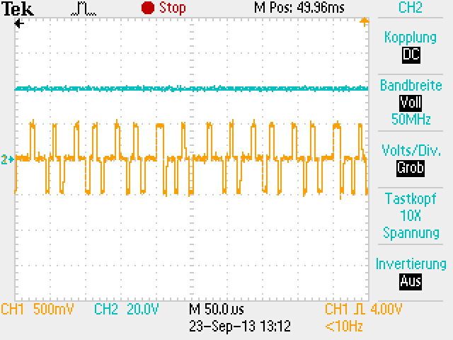

The level of the power supply voltage on the S-interface-bus is 40V.

2)

Duration of a frame:

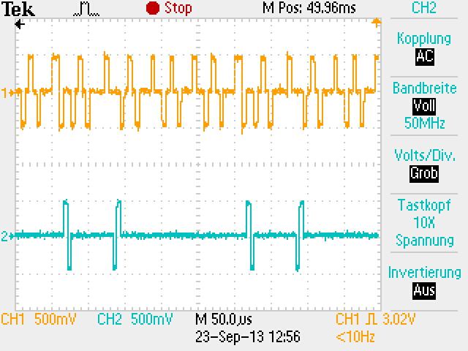

The duration of a frame is 250µs.

3)

Signal voltage:



The signal voltage (Peak) is 500mV.

4)

Bit length:

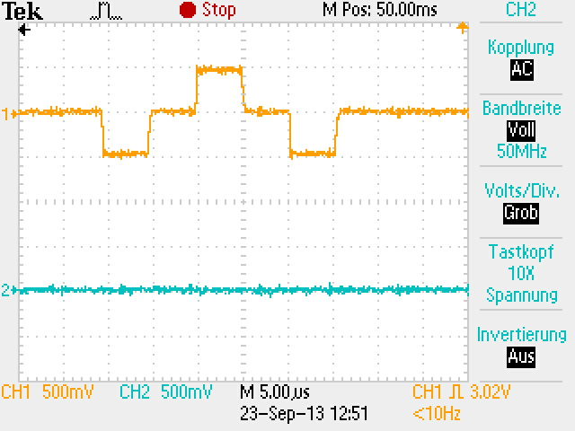

The bit length is 5µs.

5)

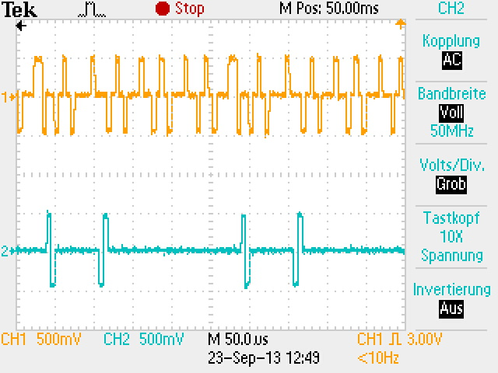 Difference in the frames during idle state and conversation state:

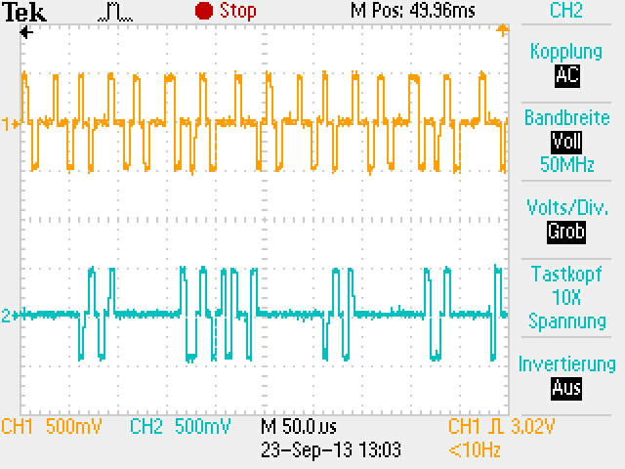

During the conversation state there are more bits transfered

than during idle state.